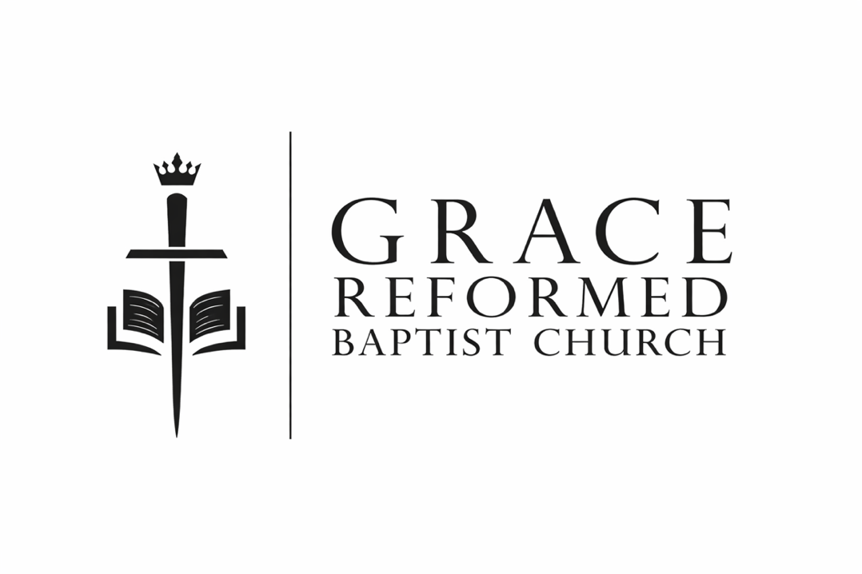

Sunday, June 14, 2026
grbcva.com

Vision Statement:
A multi-generational community of saints, living as a unified body in covenant with Christ, and joyfully advancing the Kingdom of God for His glory

Mission Statement:
Calling and equipping families to boldly worship Jesus by discipling them in the whole counsel of God’s word

Call to Worship: Ps 28:7
The Lord is my strength and my shield; My heart trusts in Him, and I am helped; Therefore my heart exults, And with my song I shall thank Him.

SONG OF ADORATION: “Come Thou Fount”

Come Thou Fount of every blessing
Tune my heart to sing Thy grace;
Streams of mercy, never ceasing,
Call for songs of loudest praise
Teach me some melodious sonnet,
Sung by flaming tongues above.
Praise the mount! I'm fixed upon it,
Mount of God's unchanging love.
Here I raise my Ebenezer;
Hither by Thy help I'm come;
And I hope, by Thy good pleasure,
Safely to arrive at home.
Jesus sought me when a stranger,
Wandering from the fold of God;
He, to rescue me from danger,
Interposed His precious blood.
​O to grace how great a debtor
Daily I'm constrained to be!
Let that grace now like a fetter,
Bind my wandering heart to Thee.
Prone to wander, Lord, I feel it,
Prone to leave the God I love;
Here's my heart, O take and seal it,
Seal it for Thy courts above.

O that day when freed from sinning,
I shall see Thy Lovely Face;
Full arrayed in blood-washed linen
How I'll sing Thy sovereign grace;
Come, my Lord, no longer tarry,
Bring Thy promises to pass
For I know Thy pow’r will keep me
Till I’m home with Thee at last.
Our Confession of Sin: Eph 2:8-10
For by grace you have been saved through faith; and that not of yourselves, it is the gift of God; ⁹ not as a result of works, so that no one may boast. ¹⁰ For we are His workmanship, created in Christ Jesus for good works, which God prepared beforehand so that we would walk in them.

HIS ASSURANCE OF PARDON:

“Grace that is Greater”
Marvelous grace of our loving Lord,
Grace that exceeds our sin and our guilt!
Yonder on Calvary’s mount outpoured,
There where the blood of the Lamb was spilled.
[CHORUS]
Grace, grace, God’s grace,
Grace that will pardon and cleanse within!
Grace, grace, God’s grace,
Grace that is greater than all our sin!
Sin and despair, like the sea waves cold,
Threaten the soul with infinite loss;
Grace that is greater, yes, grace untold,
Points to the refuge, the mighty cross.
[CHORUS]
Dark is the stain that we cannot hide;
What can avail to wash it away?
Look! There is flowing a crimson tide,
Whiter than snow you may be today.
[CHORUS]
Marvelous, infinite, matchless grace,
Freely bestowed on all who believe!
You that are longing to see His face,
Will you this moment His grace receive?
[CHORUS]

NEW CITY CATECHISM
Question 1: What is our only hope in life and death?
Answer: That we are not our own but belong to God

Question 2: What is God?
Answer: God is the creator of everyone and everything

Question 3: How many persons are there in God?
Answer: There are three persons in one God: the Father, the Son, and the Holy Spirit.

Question 4: How and why did God create us?
Answer: God created us male and female in his own image to glorify him.

Question 5: What else did God create?
Answer: God created all things and all his creation was very good.

What is a Catechism? www.newcitycatechism.com
- “Today many churches and Christian organizations publish “statements of faith” that outline their beliefs. But in the past it was expected that documents of this nature would be so biblically rich and carefully crafted that they would be memorized and used for Christian growth and training. They were written in the form of questions and answers, and were called catechisms (from the Greek katechein, which means “to teach orally or to instruct by word of mouth”)

- In his letter to the Galatians Paul writes, “Let the one who is taught the word share all good things with the one who teaches” (Gal. 6:6). The Greek word for “the one who is taught” is katechoumenos, one who is catechized. In other words, Paul is talking about a body of Christian doctrine (catechism) that was taught to them by an instructor (here the word catechizer).”

PREACHING OF HIS WORD

“The mission of GRBC: Bold Disciples”
Matthew 28:18-20

“¹⁸ And Jesus came up and spoke to them, saying, “All authority has been given to Me in heaven and on earth. ^{19 [e]}Go therefore and make disciples of all the nations, baptizing them in the name of the Father and the Son and the Holy Spirit, ²⁰ teaching them to observe all that I commanded you; and lo, I am with you ^{[f]}always, even to the end of the age.”

Sermon Notes

RESPONSE OF PRAISE:
“Come Behold the Wondrous Mystery”

Come, behold the wondrous mystery
In the dawning of the king
He the theme of Heaven's praises
Robed in frail humanity
In our longing, in our darkness
Now, the light of life has come
Look to Christ who condescended
Took on flesh to ransom us

Come, behold the wondrous mystery
He is the perfect son of man
In His living, in His suffering
Never trace nor stain of sin
See the true and better Adam
Come to save the hell-bound man
Christ, the great and sure fulfilment
Of the law in Him, we stand

Come, behold the wondrous mystery
Christ, the Lord upon the tree
In the stead of ruined sinners
Hangs the lamb in victory
See the price of our redemption
See the Father's plan unfold
Bringing many sons to glory
Grace unmeasured, love untold

Come, behold the wondrous mystery
Slain by death, the God of life
But no grave could ever restrain Him
Praise the Lord, He is alive
What a foretaste of deliverance
How unwavering our hope
Christ in power resurrected
As we will be when He comes

HELPFUL INFORMATION


Collection of Offering: For members of GRBC, giving is an act of worship. As believers in Jesus Christ, we should give with grateful hearts, not under compulsion. We are not “buying” our salvation but simply giving to help make disciples and advance His Kingdom.
Communion: Please worship God in partaking of communion only if you are a follower of Jesus and not living in consistent unrepentant sin. We are reminded of how Christ died for our sins so that we can spend eternity in Heaven with him. Both wine and grape juice are available.

Family-Integrated Worship: Ps 127:3a “Behold, children are a gift from the Lord.” They may be loud at times but we believe scripture instructs parents to teach their kids how to worship. We do have a mother’s room available in the back left.

ANNOUNCEMENTS:
Community Group: Join us here Tuesday 6:00-8:00 for food, fellowship and kid’s catechism.

Men’s Bible Study on Psalms every Friday morning at 6:30 at McDonalds on 301 in Mechanicsville. This week: Psalm 8.

Youth Group: 6th grade and up will not meet in June. Summer camp is Aug 2-7. Contact Matt Stewart for details.

Thank you for joining us at Grace Reformed Baptist Church.


Join us on Slack!

